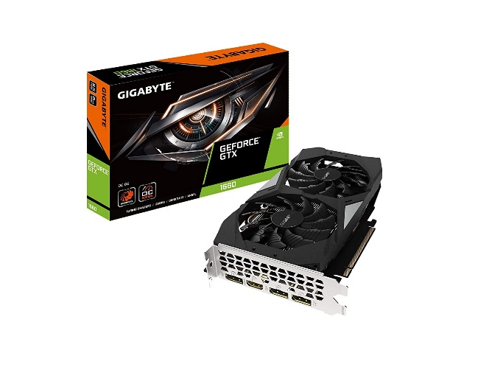

Inner

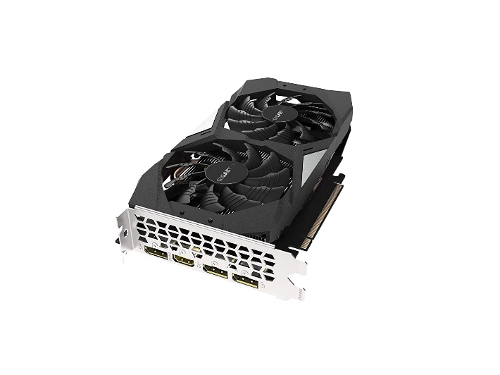\

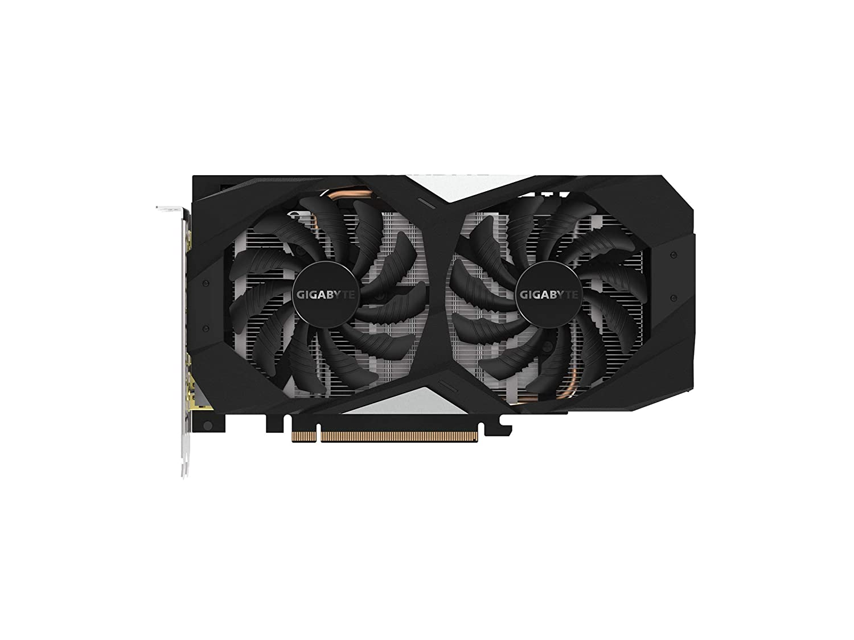

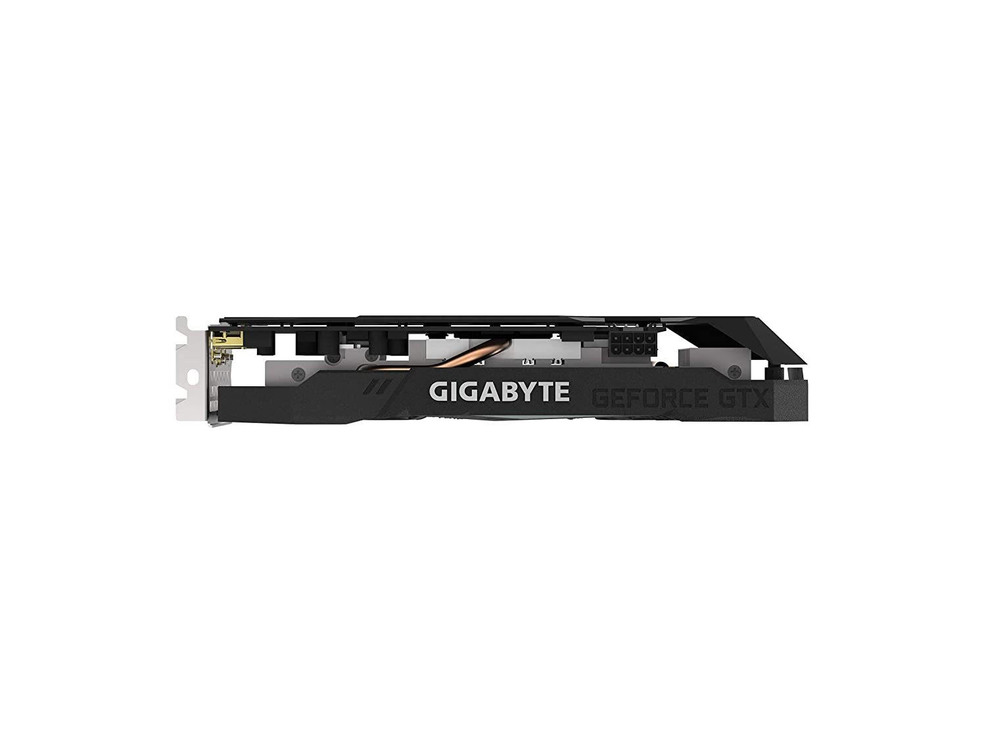

GIGABYTE GeForce GTX 1660 pci_e_x16 OC 6GB GDDR5 Graphics Card, 2X Windforce Fans, (GV-N1660OC-6GD)

-62% ₹29,999₹29,999

M.R.P.: ₹78,999₹78,999

|  |  |
| --- | --- |
| Graphics Coprocessor | NVIDIA GeForce GTX 1660 |
| Brand | GIGABYTE |
| Graphics RAM Size | 6 GB |
| GPU Clock Speed | 2 GHz |
| Graphics Processor Manufacturer | NVIDIA |

**About this item**

* Powered by GeForce GTX 1660
* Integrated with 6GB GDDR5 192-bit memory interface
* WINDFORCE 2X Cooling System with alternate spinning fans. OC Edition